|  |  |
| --- | --- |
| **Ex.No.8** | **Zener diode current-voltage characteristics** |
| **Date:**  **2-12-2021** |

AIM:

To find out the break down voltage of Zener diode

Components and Equipment required:

|  |  |  |  |  |
| --- | --- | --- | --- | --- |
| **SL.**  **NO.** | **NAME OF THE APPARATUS** | **RANGE** | **TYPE** | **Quantity** |
| **1** | **Regulated power supply** | **0-30 V** |  | **1 No** |
| **2** | **Volt meter (DMM)** |  |  | **1 No** |
| **3** | **Ammeter (DMM)** |  |  | **1 NO** |
| **4** | **Zener Diode** | **-** |  | **1No** |
| **5** | **Breadboard** | **-** | **-** | **1 No** |

THEORY:

**The *Zener diode* is the simplest types of voltage regulator and the point at which a Zener diode breaks down or conducts is called the “Zener Voltage” (Vz).**

**The Zener diode is like a general-purpose signal diode consisting of a silicon PN junction. When biased in the forward direction it behaves just like a normal signal diode passing the rated current, but as soon as a reverse voltage applied across the Zener diode exceeds the rated voltage of the device, the diode breakdown voltage is reached. The current now flowing through the Zener diode increases rapidly to the maximum circuit value (which is limited by a series resistor) and once achieved this reverse saturation current remains fairly constant over a wide range of applied voltages. The voltage points at which the voltage across the Zener diode becomes constant is called the “Zener voltage”.**

**Circuit Diagram:**

**Forward bias:**

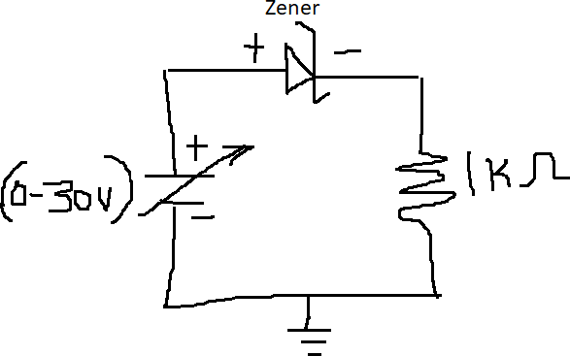

**Reverse bias:**

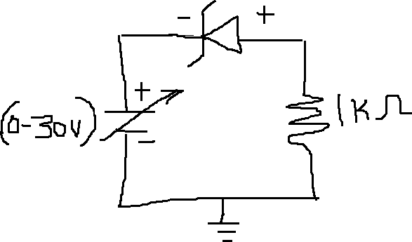

PROCEDURE:

FORWARD BIAS:

1. **The connections are made as shown in the circuit diagram.**
2. **For forward bias the positive terminal of power supply is connected to anode of the diode, negative terminal to cathode.**
3. **The power supply is switched on.**
4. **The forward voltage Vf across the diode is increased in small steps and the forward current is noted.**
5. **The readings are tabulated.**
6. **A graph is drawn between Vf and If by taking Vf along x-axis.**
7. **The inverse of the slope of the linear portion of the graph gives the forward resistance Rf of the diode Rf=Vf/ If.**

REVERSE BIAS:

1. **For reverse bias the positive terminal of the power supply connected to cathode of the diode and the negative terminal to the anode of the diode.**
2. **The power supply is switched on.**
3. **The reverse bias voltage Vr is increased in steps and reverse current Ir is noted in each step.**
4. **The readings are tabulated.**
5. **A graph is drawn between Vr and Ir taking Vr on x-axis. The reverse characteristics curve is approximately a straight line.**

TABULATIONS:

|  |  |  |  |  |
| --- | --- | --- | --- | --- |
| **RPS** | **FORWARD BIAS** | | **REVERSE BIAS** | |
| **Vsupply** | **Vf (V)** | **If(mA)** | **Vr (V)** | **Ir** |
| **0.1** | 0.099 V | 0.020 mA | 0.099 V | 19.99 nA |
| **0.2** | 0.199 V | 0.042 mA | 0.199 V | 39.99 nA |
| **0.5** | 0.456 V | 0.043 mA | 0.499 V | 99.98 nA |
| **0.7 V** | 0.497 V | 0.202 mA | 0.699 V | 139.97 nA |
| **1 V** | 0.519 V | 0.480 mA | 0.999 V | 199.97 nA |
| **2 V** | 0.548 V | 1.45 mA | 1.99 V | 349.9 nA |
| **3V** | 0.561 V | 2.43 mA | 2.99 V | 599.9 nA |
| **4V** | 0.570 V | 3.42 mA | 3.99 V | 799.8 nA |
| **5V** | 0.577 V | 4.42 mA | 4.894 V | 105.1 μA |
| **6V** | 0.582 V | 5.41 mA | 4.91 V | 1.058 mA |
| **10V** | 0.597 V | 9.40 mA | 4.97 V | 5.027 mA |
| **15V** | 0.608 V | 14.39 mA | 4.936 V | 10.01 mA |
| **20V** | 0.615 V | 19.38 mA | 4.994 V | 15.0 mA |
| **25V** | 0.621 V | 24.37 mA | 5 V | 20 mA |
| **30V** | 0.626 V | 29.37 mA | 5 V | 25 mA |



GRAPH:

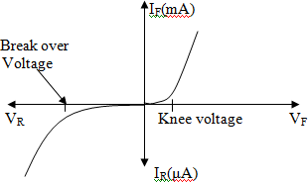

RESULT:

The forward and reverse characteristics of the Zener diode has been plotted

The Zener breakdown voltage of the diode = ---------

PRECAUTIONS:

1. **Always connect the voltmeter in parallel & ammeter in series as shown in figure.**
2. **Connection should be proper & tight.**
3. **Switch ‘ON the supply after completing the circuit.**
4. **DC supply should be increased slowly in steps.**
5. **Reading of voltmeter and ammeter should be accurate**